**ENGINEERING JOURNAL LOG 3**

03/11/19

# Tasks

Test power supply with virtual ground

Build Coils

Build Oscillator

# Reflection

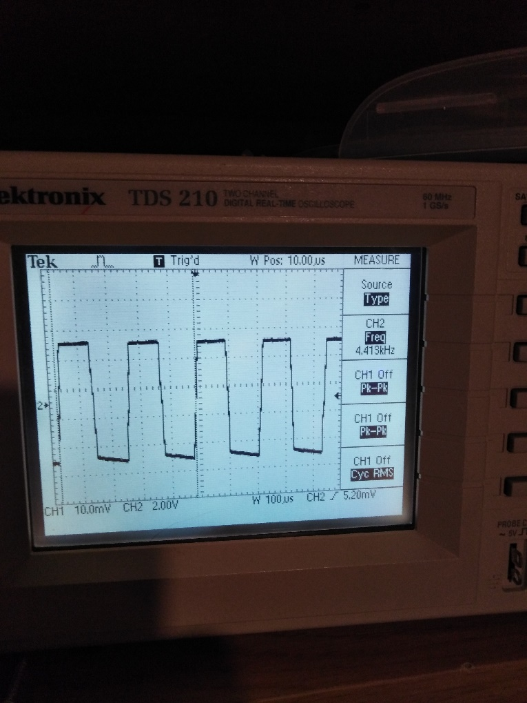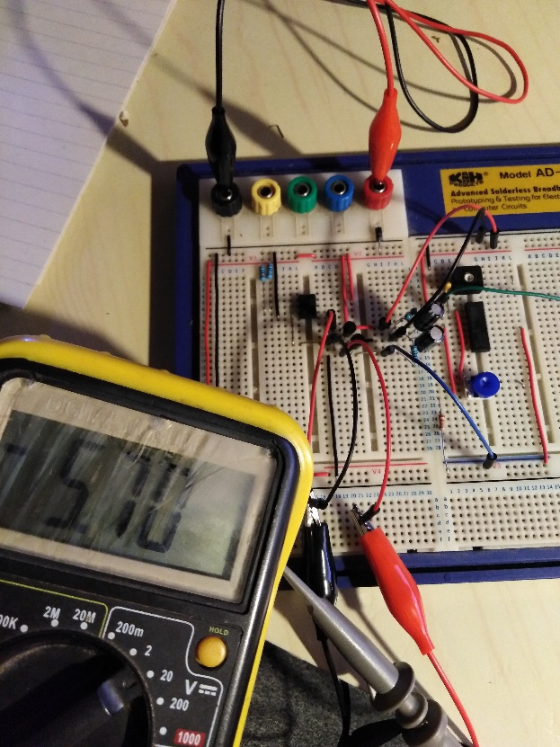Parts were sourced and circuits sketched. Started building power supply which will split 12 volts and create the virtual ground. Idea was to use an op-amp to stabilize the virtual ground line and 2 transistors (NPN and PNP) to help supply current for op-amps. After building the circuit I measured outputs. Multimeter shoved the positive side of +5.8v and negative side -5.8 volts. I started adding some load on outputs and voltage started shifting. I tried to add a bigger capacitor on output and added ceramic caps on the input of the rail voltage output stabilized. Connected power to quad op-amp which will work as the first stage of the oscillator. Op-amp outputs imperfect square waveform need some tweaking.

Picture 1. Split power supply and op-amp

Picture 2. Op-amp output

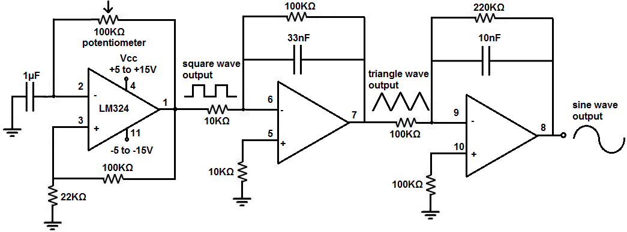Picture 3 Schematic for oscillator

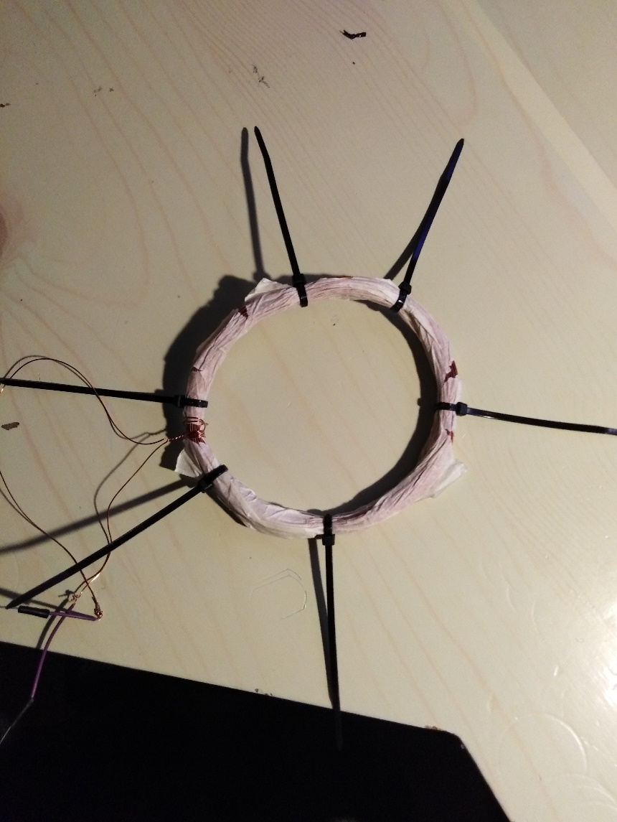

TX coil I made from copper vire 0.4mm thickness. I winded 140 times on circular object with a diameter of 9.5cm coil have approximately 3.3mH of inductance. TX coil I will try to produce with the double number of turn, but first I need to complete a sketch of demodulator and integrator circuits where signals will be composed appropriately for MCU to accept the signal and process it.

Picture 4. TX coil